Amazon Web Services

**Life Cycle Management**

# Life Cycle Management

* It is a way of efficiently managing the objects so that the cost is minimized throughout the lifecycle of the lifecycle of the object inside the instance. 1000 lifecycle rules can be configured per bucket
* There are two types of actions:
* **Transition actions**: in which the storage class for the objects changes
* **Expiration actions**: where the objects expire and are permanently deleted

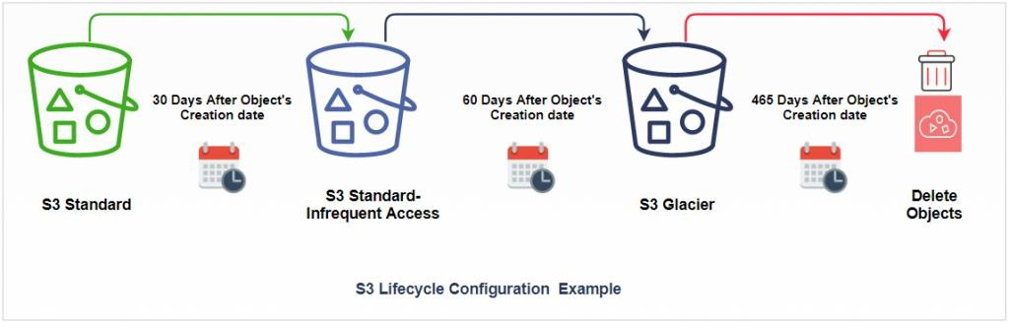

# Life Cycle Management - Rules

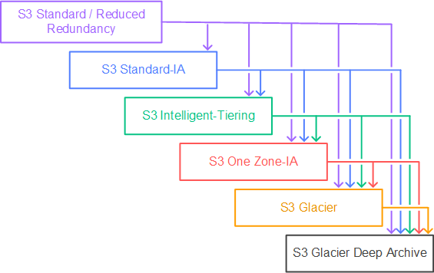

Life Cycle Management

* + Create Bucket
  + Select ACLs Enabled
  + Give Public Access
  + Upload the object
  + Give the Public Access
  + Open bucket
  + Go to the Management tab

# Life Cycle Management

* + Click on Create lifecycle rule
  + Enter the Name
  + Select this rule applies to all objects in the bucket
  + Acknowledge the rule
  + Select the rules as per our client's requirements
  + Select storage classes

# Life Cycle Management

* + Select the class & enter the days
  + Check the timeline summary
  + Click on create rule